**Requirements for maintaing attendance management system**

**Attendance management system:** It is a cloud bases HR tech tool that enables organizations to automate their attendance management operations and keep track of employee working hours.

The client needs a software for managing attendance of employee

**Requirements**

1. The software should consist of format sheet that can store the details of the employee such as Employee name, Address, Phone number, Employee ID, Email-ID etc.

2. The software should have a facility of biometric login and logout with timings or they can also give their attendance by using employee ID.

3. The employee details should be properly authenticated, so that employees give attendance through biometric login or by using employee ID, so that attendance will be given to a specific employee

4. When the employee takes a paid leave it should be registered in a paid leave section and when the employee takes a non-paid leave then it should be registered in non-paid leave section, such in-built feature should be there in the software.

5. The software should have the in-built feature of using the employee ID to give attendance only when the employee is on paid leave and cannot use biometric login.

6. There should be in-built feature to assign and calculate the salary as per the employee’s attendance.

7. There should be a facility to store the records and modify them whenever changes are required in the software.

8. The software should be secured to prevent unauthorized access to employee data. This can include features, such as user authentication, data encryption and access control.

9. Regular maintenance is essential to keep the software run smoothly which avoids the arise of problems or issues.

**Risks involved in Attendance management system**

1. An attendance management system collects and store sensitive personal information about employees, such as their work schedules, attendance records and biometric data. This information needs to be protected from authorized access or misuse.

2. Attendance management systems rely on accurate data to generate reports and make decisions about employee’s attendance. Inaccurate data can result in incorrect pay, disciplinary action or other issues.

3. Attendance management system needs to comply with relevant laws and regulation such as data and privacy laws if they don’t follow the laws and regulation they must pay penalities to overcome this risk.

4. Any failure in the software can result in accurate data or loss records. This can cause disruptions to payroll processing and other business operations.

**Steps of Jira for managing the project to solve the identified problem.**

**STEP-1: In the name icon enter your project name and click on**

**Create**

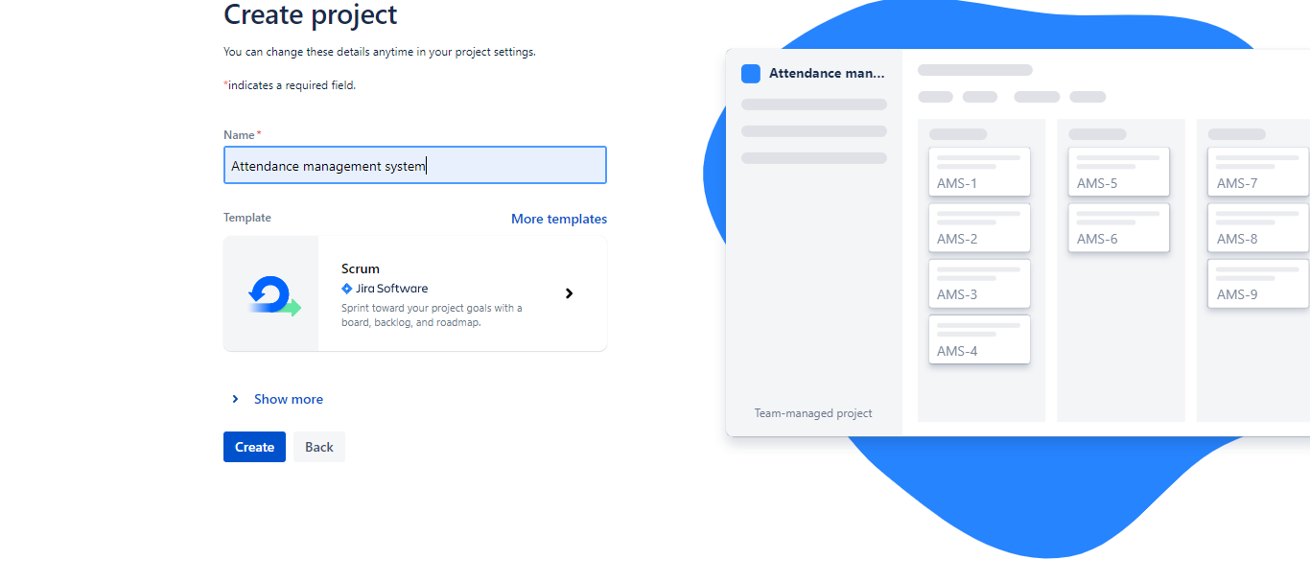

**STEP-2: Click on Project button -> Your created projects will be**

**Displayed**

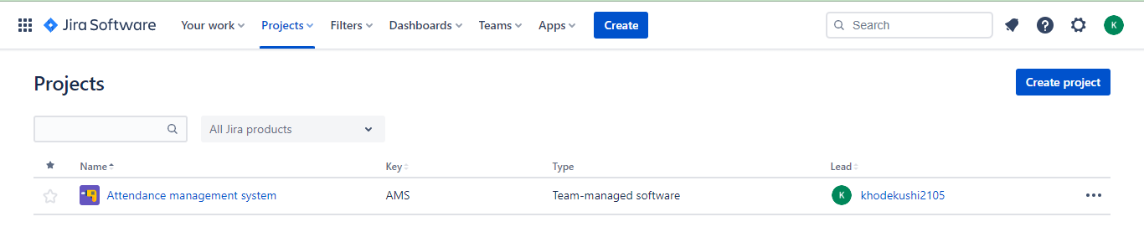

**STEP-3: Click on backlog button and create issue in backlog. Drag**

**the issues from backlog to sprint**

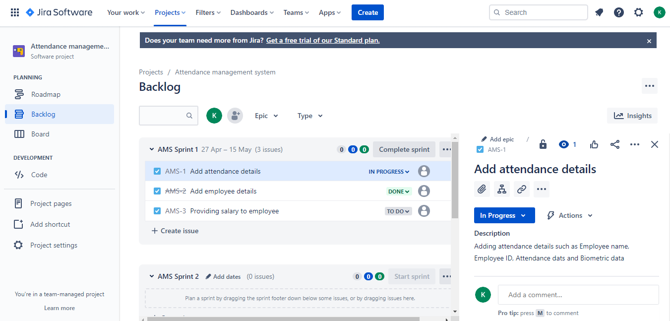

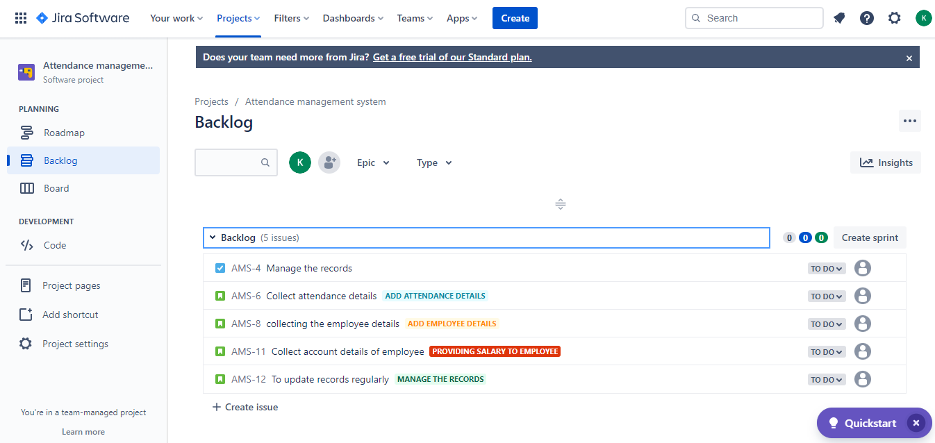

**STEP-4: Click on board and drag the issues to its respected fields**

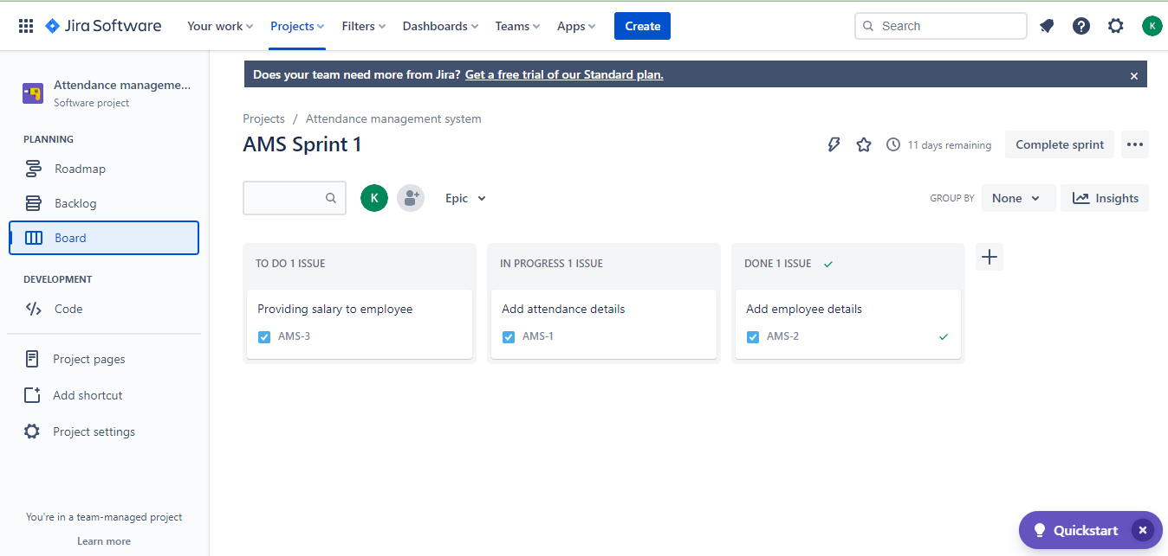

**STEP-5: Click on roadmap and create Epic and child process**

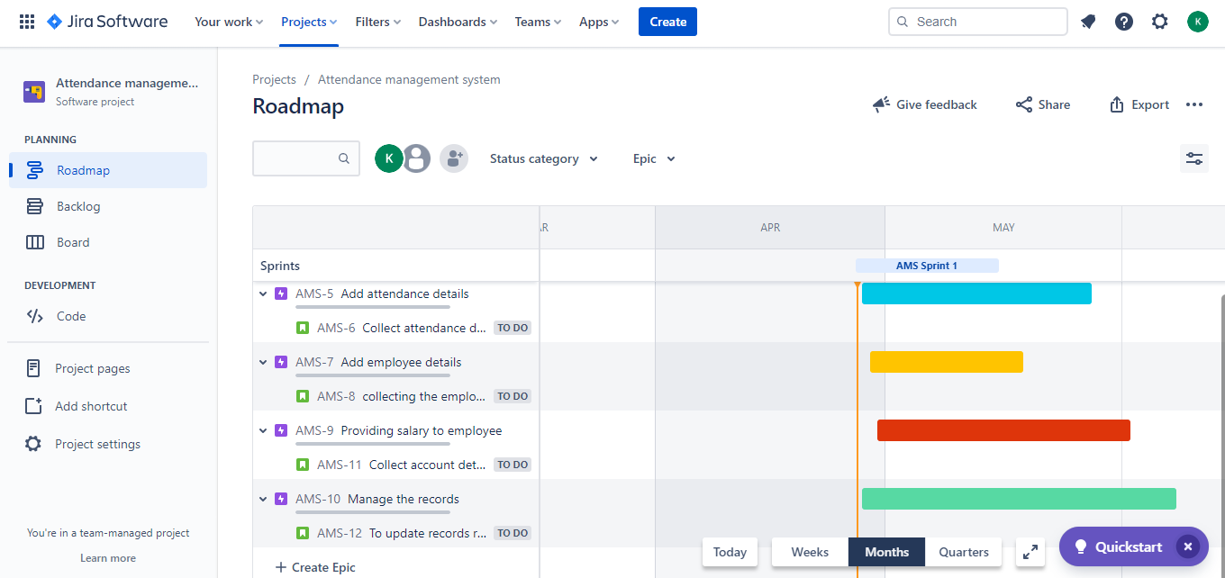

**STEP-6: Share the project with users.**

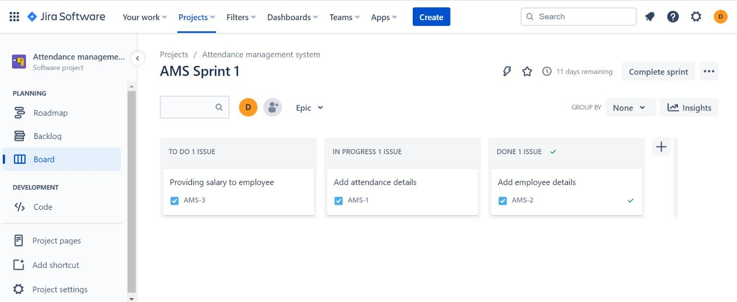

**UML Diagram of our Requirement**

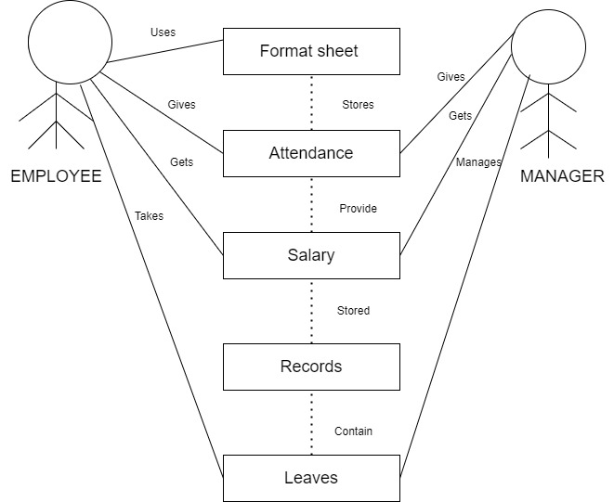

**User story of our Requirements**

|  |  |  |
| --- | --- | --- |
| **Title: Attendance details** | **Priority: High** | **Estimate: 2** |
| User story – Employee  As a First time user of a Attendance Management website,  I want to enter attendance of employees  So that the attendance of the employee can be maintained | | |
| Acceptance criteria  Given that the new user wants to enter attendance of the employees using website,  When the attendance of employees will be entered  Then the attendance of the employee will be maintained in a proper sequence | | |

|  |  |  |
| --- | --- | --- |
| **Title: Managing the records** | **Priority: Low** | **Estimate: 2** |
| User story – Manager  As a manager of Attendance management system,  I want to maintain in detailed attendance of a employee  So that the records are well maintained | | |
| Acceptance criteria  Given that the manager of attendance management system wants to maintain attendance of employees,  When they manage the attendance in detail then the records will be well maintained | | |

**Step-1: Install Zephyr scale-Test management for JIRA**

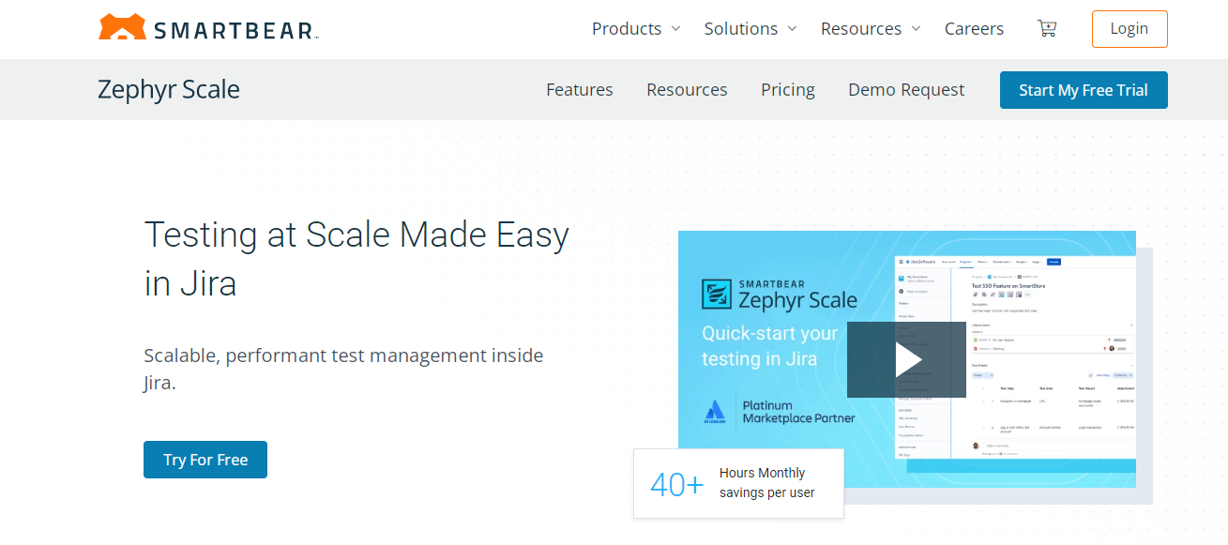

**Step-2: Create test suite(case) for your project**

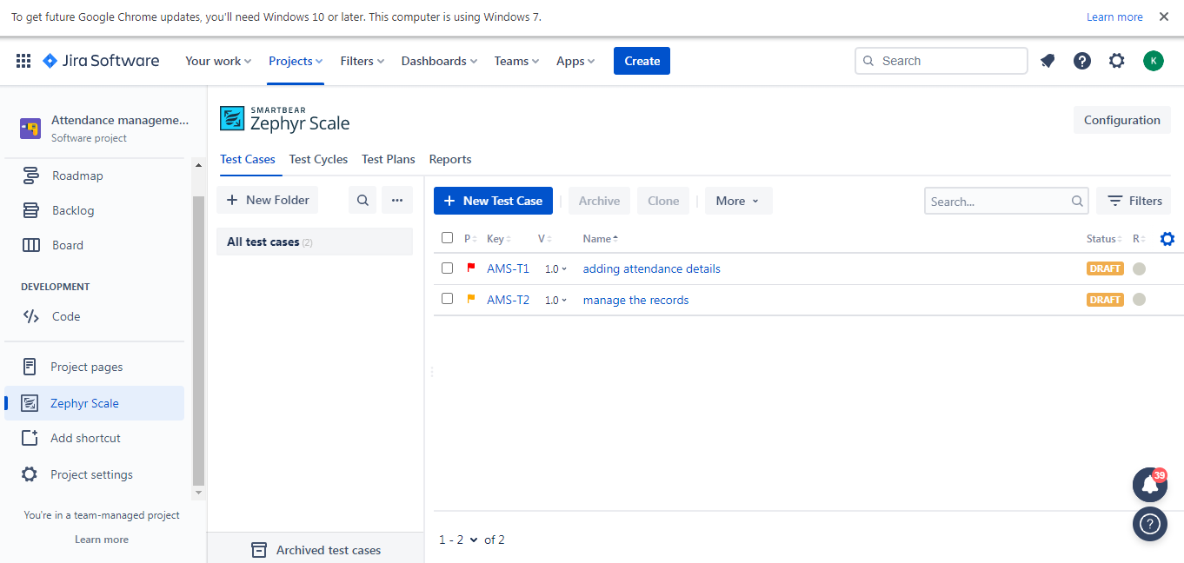

**Step-3: Add details for your test suite(case)**

